System Architecture

1. System Goals

Our team is responsible for developing the Android side and WeChat applet of the scoliosis detection system. Among them, the target users of Android are doctors, and the target users of WeChat applet are patients and their families. The patient uploads the spine x-ray inspection map through the WeChat applet, and obtains the artificial intelligence test result, and the patient can also view the historical test record. Doctors can view the test results of a certain patient through the Android terminal, and can manually modify the auxiliary lines and modify the data if necessary.

1. System premise

WeChat small program:

1. Small program terminal is only for non-professional users such as family members

2. Applets are limited to mobile phones without considering other screen sizes

3. Users need WeChat client support of iOS 6.5.8 / android 6.5.7 or above

Android:

1. Andorid is only for professional users such as doctors, and is only used within professional institutions such as hospitals

2. Android terminal devices are limited to large-screen Android tablet devices, and mobile phone adaptation is not required

3. The device requires Android 6.0 or above

1. System description
   1. Flow chart
2. Login (User: Patient)

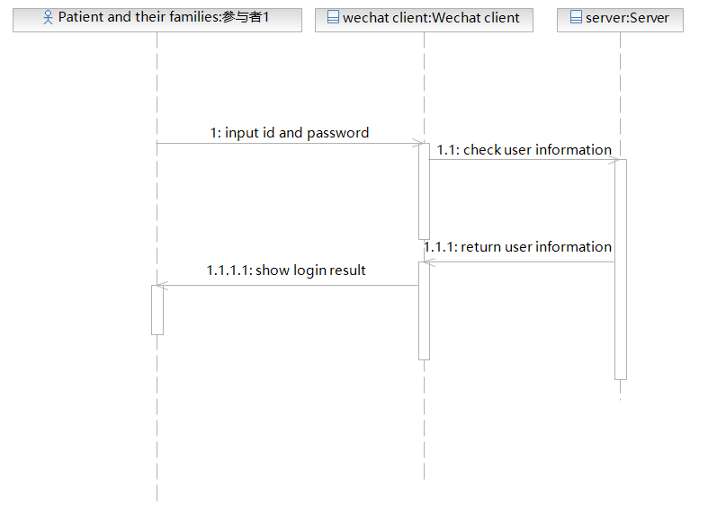

1. Login (User: Doctor)

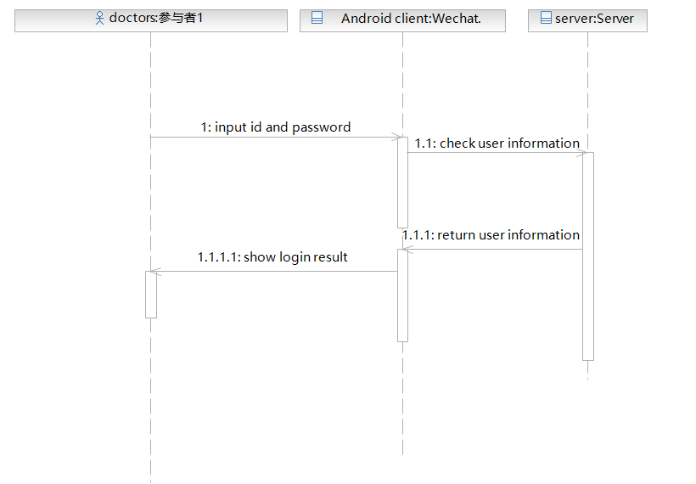

1. Use a detection engine to detect pictures (users: patients and their families)

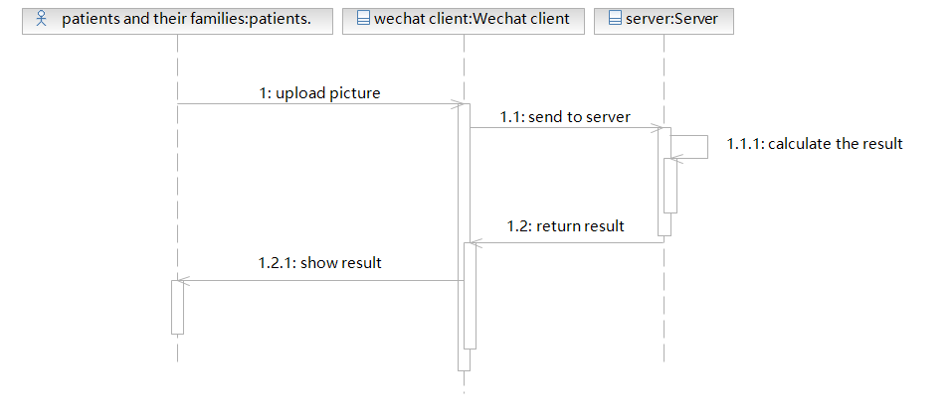

1. Upload training data (user: doctor)

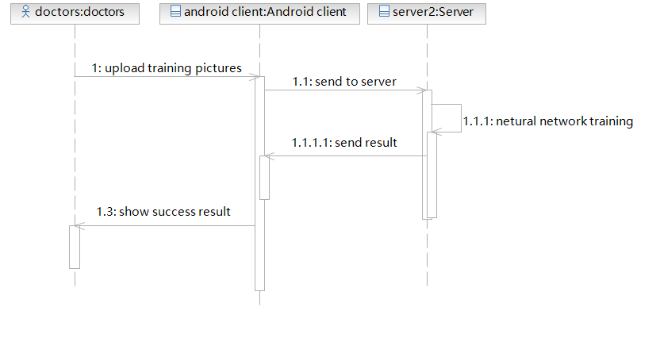

1. View historical records (Users: patients and their families)

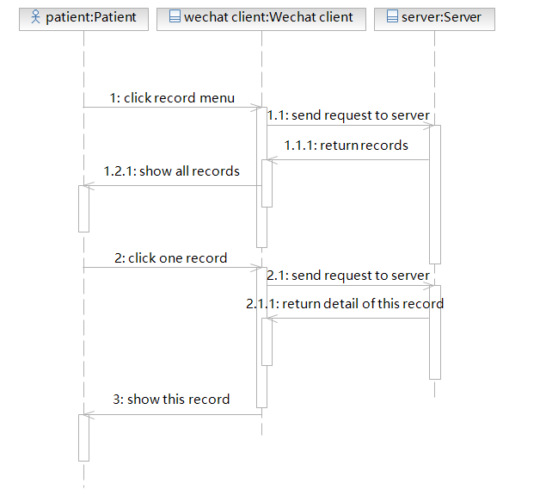

1. View history (user: doctor)

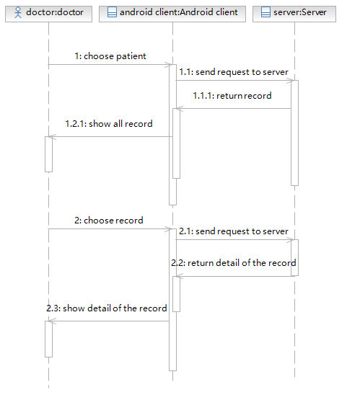

1. Manually modify the auxiliary line (user: doctor)

